Star Island Corporation (SIC)
Chief Executive Officer’s Report
June 13, 2017

Our Mission: To own and maintain Star Island and such other property as the Corporation may hold or acquire, as a center for religious, educational, and kindred purposes consistent with the principles of the Unitarian Universalist Association and the United Church of Christ.

Our Vision: To create on Star Island an environment that frees all who come to renew spiritually, explore matters of consequence, and gain knowledge about the world as it might ideally be.

COMMUNITY

- The joint SIC staff/IRAS marketing team met on May 18 to discuss several topics. We are pleased that our work together – which dates back well over a year – is seeming to make a difference, as IRAS enrollment as of June 1 is 12% higher than budget, and 14% higher than IRAS’ 2016 final enrollment. On June 26, we will meet on island to map out our strategies for 2018 and beyond.
- Another example of our long-term marketing plan involves favorable media coverage, positioning us as thought leaders and demonstrating how we are living our vision and values. A recent example of this, which focuses on both individual conferences and Star Island as a whole can be found at www.seacoastonline.com/news/20170515/environmental-issues-take-center-stage-at-star-island.
- The Pelican Compensation Task Force (PCTF) continues to work towards a long-term Pelican compensation recommendation to present to the staff and Board in August. Most recently, the PCTF met on June 1, and discussed several topics, including the importance of non-monetary compensation such as housing and food.
- Our SEA Star Program pilot was effectively run with Grantham (NH) Village School’s and North Hampton (NH) School’s fourth grade classes. The program included us presenting at each school, and each school having a field trip on Star Island. In addition to very successful programs, we learned a lot to further refine our SEA Star Program in the future.
- We are pleased to be hosting the Yearly Adults and Star Island Paranormal Conferences this week, and to welcome Star Arts and Natural History Week to the island next week. One upcoming island-wide event we are looking forward to is Bread & Puppet Circus, which will perform on June 21 as part of Natural History Week’s programming. Bread & Puppet on Star Island is made possible by the generous support of several individuals and organizations, including Natural History Week, Star Arts, the Pelicans, the Isles of Shoals Association, UU, Star Island Corporation, the Fuller Foundation, the Unitarian Universalist Church of Concord, NH, and some generous individual donors.
- Pelican orientation week kicked off yesterday, with the arrival of our regular season Pelicans, a general orientation session led by John Bynum, Island Manager, and a community covenant session facilitated by Chris Jablonski, Island Minister. During the general orientation session, Dave Boynton and I both had the opportunity to share with the Pelicans why we felt being a Pelican was a meaningful opportunity. Orientation continues throughout this week, focusing on crew-specific training, hospitality, safety, logistics, and several other topics. The staff will receive training from staff and a number of outside experts. It is evident that we have an engaged and friendly group of Pels this year.
- On Thursday, the Rye Police Department (RPD) is scheduled to provide training to select senior staff members on how to respond to an active shooter situation. While horrible to contemplate, this training is nonetheless important for key staff members, and we are grateful to RPD for providing this training.
- Working with our professional media consultant, we have drafted a crisis communications plan that spells out specific protocols for responding to media requests that might lead to unfavorable press. This is another proactive measure we are taking to prepare ourselves for something that we simultaneously strive to avoid needing in the first place.
- Please find attached a sabbatical policy recommendation from the Personnel Committee, which will be discussed at the June 17 Board meeting.
- We are working with a pension expert at Insource Services, our professional human resources and finance consultants, on a number of aspects related to our pension plan, currently offered through TIAA-CREF. In addition to our annual filing of Form 5500, we are bringing in a financial advisory firm to offer additional services to eligible employees and to conduct a thorough review of our current plan, including looking at alternative options. We look forward to working with the Personnel Committee on this, starting in September.
- Our Unitarian Universalist Alliance of Camps and Conference Centers (UUACCC) presence at the General Assembly of the Unitarian Universalist Association takes place next week in New Orleans, LA. At our UUACCC shared booth, we will be fostering and promoting the success, growth and well-being of Unitarian Universalist camps, retreat and conference centers. We are grateful to Dan Gottfried of Unirondack, Hilary Goller Hansell of U-Bar-U, and Rev. Deanna Vandiver of the Center for Ethical Living and Social Justice Renewal for serving as our booth anchors this year.

ECONOMIC

- As of June 1, we received 3,028 registrations representing 17,503 bed nights (86% of our 20,350 bed night goal). Please see the attached bed night report for more details. Last year at this time, we had registrations for 17,363 bed nights (88% of our 2016 goal), and in 2015 at this time, we had 16,066 bed nights (82% of our 2015 goal). Overall, we are pleased to be roughly on pace compared to last year, and we are optimistic that we will meet our budgeted bed night goal for this season. As of June 1, we needed to achieve 2,847 (net of cancelations) bed nights to reach our budgeted goal.
- The May Financials are expected to be completed on schedule, by Monday, June 19. At this time, we do not foresee any significant changes in our projections compared to those presented in the April Financials.
- The Finance Committee met on May 17 to discuss the April Financials, a draft five year financial plan (2017-2021), and aspects of the proposed CWSRF financing for our wastewater treatment/water reclamation facility. On the last point, a discussion about possible collateral arrangements resulted in consensus that a mortgage was preferable to using the assets of the Permanent Trust. As for the financials, a follow up meeting with me, John Bush and Chris Bertoncini and Kate Mombourquette of Insource resulted in some tweaks we expect to make to the format of the financials starting this month. The committee meets again on June 21.
- Staff has prepared a draft multi-year Capital Improvement Plan (CIP), which is now ready to send to various committees for feedback. Our goal is to finalize the CIP by early September, after which time it can be added to our Long Range Integrated Financial Planning Tool, along with other components, such as the five year financial plan and the development perspective. Our annual update to our Long Range Integrated Financial Planning Tool is expected to be completed by September or October, at which time it will go before the Board for review and comment.
- We are making great progress with finalizing Clean Water State Revolving Fund (CWSRF) loan documents for a $947,500 loan, fixed at 2.00%, for a 20 year term. After review by our small working group, we submitted our requests to the NH Department of Environmental Services (NHDES), who in turn agreed to our requests. Our respective attorneys have finalized the loan documents to our mutual satisfaction, and the NHDES is in the process of getting our loan on the July 19 NH Governor and Executive Council meeting agenda, when it is expected to be approved. In the meantime, we are busy gathering items indicated on the closing agenda provided by the NHDES, including corporate documents, title insurance and policy insuring the mortgage, and the like. We have set a closing date of Monday, July 24, and Acting CEO Dave Boynton is expected to sign all of the documents at that time – it is important to note that we anticipate all of the documents being finalized and agreed upon prior to my departure for extended leave on June 26.
- We just started borrowing from our credit line with Optima Bank. While we still rely on this important cash flow vehicle, it is reassuring to know that we didn’t need to use it for nearly ten of the last twelve months.

ENVIRONMENT

- 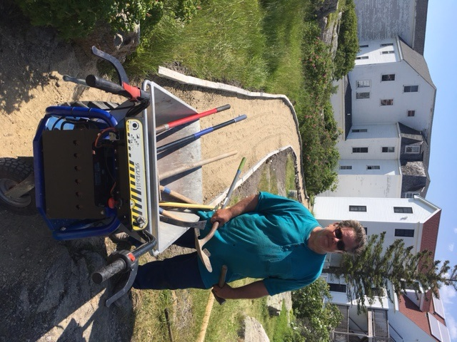We are in the final stages of a successful open-up, which is resulting in some major improvements and the island being ready for conferees. Major projects include work to/in Vaughn Cottage, the Kiddie Barn/Starloft, Oceanic 2nd floor, the Summer House, and the Chapel path. We are grateful to Tom Coleman for his significant volunteer contributions to the Chapel path project, which is an important accessibility effort.
- Our fire safety inspection took place on May 19, during which our 2017 occupancy and controlled burn permits were issued. Two members of the Rye Fire Department (RFD) were present, as well as the Rye Code Enforcement Officer and the principal from SFC Engineering, our fire safety consultant. RFD was very pleased with the state of the island and its fire systems. As per usual, there are a few items for follow up. Longer term, updating egress and fire separation in between spaces in the Underworld remains a top priority. RFD will return on Thursday for staff training. Overall, the inspection, which included all of the principal buildings, was very cordial and collaborative, as has been the experience over the past several years.
- Jack Farrell will be attending the June 17 Board meeting to provide a detailed report on our facilities, with particular emphasis on our accomplishments this spring as well as some of our larger projects on the horizon.
- Our attorney has received a signed license agreement from a property owner on Appledore Island, which provides the property owner with a revocable license to use abutting Star Island Corporation property for specific uses, such as solar panels. The license agreement fully protects Star’s property rights.
- 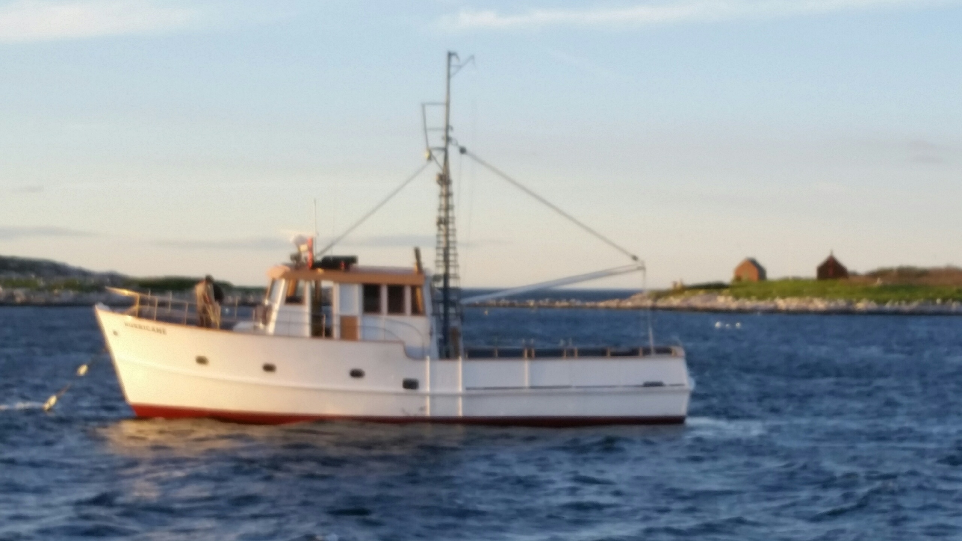The M/V Hurricane, pictured to the right, is our newest work boat, serving in essentially the same capacity as the M/V Perseverance, which remains in dry dock (readily able to be launched, if needed). The Hurricane, like the M/V Utopia but not the Perseverance, is able to carry paying passengers.
- Generally speaking, our approach to regulatory compliance is proactive and collaborative, and we have formed good relationships with many in the regulatory community. In order to keep us in compliance with myriad regulatory requirements, including filings, we keep and maintain a dynamic workbook that serves as a repository for licenses, registrations, permits, and related materials. This workbook includes a compilation of details for each regulatory filing requirement, including: regulatory authority; contacts; compliance and renewal/revision requirements, schedules, and timelines; links to forms, fact sheets, and helpful information; passwords and log-ins for online submissions and renewals; ID numbers; personnel requirements (e.g. licensing, vaccinations); status of the filing requirement (e.g. active, expired); and which staff member is responsible for the entry. Our regulatory compliance program also includes a checklist/calendar, which includes due dates for all regulatory filing requirements. Additionally, key regulatory due dates are set as recurrences on my (digital) calendar, as well as on Office Manager Kate Brady’s calendar.

STEWARDSHIP
(NOTE: Director of Development Pam Smith and I have co-written this part of my report.)
- As of May 31, our Annual Fund (AF) had realized $99,962 in gifts, with a pledge balance of $8,725, for a total of $108,687 (22% of our 2017 goal of $490,000). Please see the attached May AF Comparison Report for more information. The following chart compares our progress this year to the previous two years:
Year | Realized Gifts | Pledge Balance | Total | % to Goal | Total Donors
2017 | $99,962 | $8,725 | $108,687 | 22% | 327
2016 | $103,388 | $9,580 | $112,968 | 24% | 323
2015 | $80,969 | $6,350 | $74,619 | 16% | 233

- We enjoyed “Celebrating our Stars!” – our off-island donor and volunteer appreciation event which took place at the Kittery Community Center on May 23. This was the first off-island donor recognition event Star has hosted in many years, and over 50 people attended the reception, which was followed by an encore presentation of “Secrets, Scalawags and Spirits of the Isles of Shoals” by Ann Beattie, and Wendy Lull, former Executive Director of the Seacoast Science Center.
- On June 8, a community networking event was co-hosted by Star Island and Tributary Brewery, a local business (Kittery, ME) which supports many environmental organizations. Staff had great conversations with many people from the Seacoast Region, sharing information about Star Island and our Green Gosport Initiative.
- Later today, Star Island is partnering with Fuller Gardens in North Hampton, NH, to host an event called “Poetry in the Gardens” featuring former Portsmouth Poet Laureate Kate Leigh. Kate will read poetry from the Shoals, and proceeds from the event will be split between Fuller Gardens and Star Island. Fuller Gardens is owned and managed by the Fuller Foundation, a Star Island supporter.
- We have recently received three grants, all of which cover budgeted expenses for this fiscal year. Two of these grants directly support conference programming, which is a new strategy we tried this spring. The grants are:
  - $12,500 from the Hunt Foundation, in support of our Green Gosport Initiative.
  - $3,500 from the Fuller Foundation, in support of the Bread & Puppet event occurring during Star Arts/Natural History Week, and also the Chamber Music Conference.
  - $2,200 from the Madelaine Von Weber Trust, in support of the Chamber Music Conference.
- By June 23, we will apply to the Land and Community Heritage Investment Program (LCHIP) for $125,000 for continued rehabilitation work on the Oceanic Hotel. We have reduced our ask amount by $25,000 in order to avoid a perpetual easement requirement, though we are in the process of investigating this option for the future.
- Our newsletter, including our annual recognition listings, is expected to be in people’s mailboxes this week.
- Please find attached a presentation about our 2017-2018 Board meeting calendar, which will be discussed at the Board meeting on June 17.
- We are in the production phase of wall panels focusing on the history of fishing at the Isles of Shoals. We anticipate the five panel display being installed in Brookfield in advance of All Star 1, during which time we intend to host an unveiling ceremony.
- We benefited from several spring volunteer weekends this year. Volunteers cleaned rooms, completely cleaned and stocked the First Aid Station, weed-whacked and mowed, repaired dozens of chairs, helped establish/maintain the flower and vegetable gardens, painted several rooms, completed carpentry projects, and much more. We would not be able to accomplish all that needs doing on Star Island without our amazing volunteers.

We are off to a great start to our conference season, and we look forward to an enjoyable and meaningful season for all who come to Star Island this year. I am also looking forward to my time away, and have every confidence in the talented and dedicated leadership team we are fortunate to have in place. I am especially grateful to Dave Boynton, who will be serving as Acting CEO, June 26-August 20.

With Star Spirit,
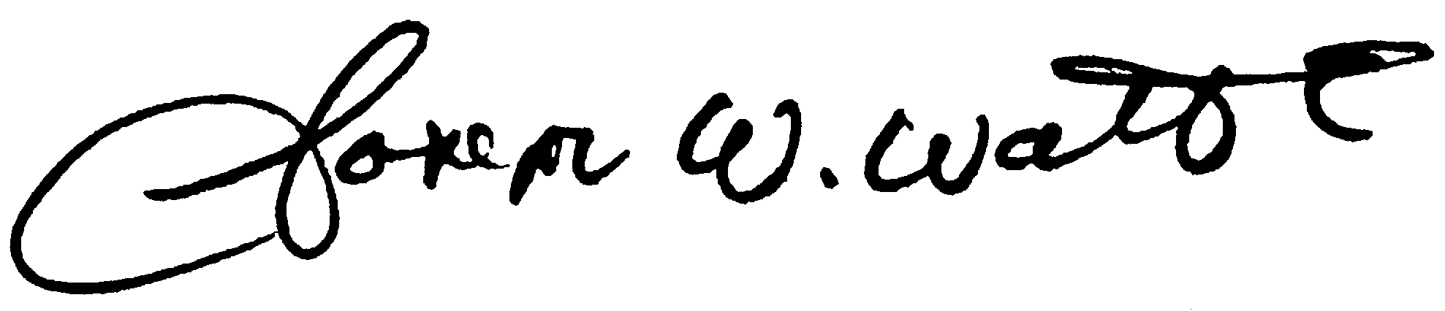
Joe Watts
Chief Executive Officer

