Star Island Corporation (SIC)
Chief Executive Officer’s Report
April 18, 2017

Our Mission: To own and maintain Star Island and such other property as the Corporation may hold or acquire, as a center for religious, educational, and kindred purposes consistent with the principles of the Unitarian Universalist Association and the United Church of Christ.

Our Vision: To create on Star Island an environment that frees all who come to renew spiritually, explore matters of consequence, and gain knowledge about the world as it might ideally be.

COMMUNITY

- The Conference Services Committee (CSC) conducted two surveys in March seeking input from conferees on the experience of bringing kids to Star and also life on Star with disabilities. Well over 100 people responded to each survey, and the feedback has been informative and useful. The CSC met on April 6 to discuss the results and form an action plan, much of which will be implemented this year. The surveys will continue to stay open throughout the conference season, and will be promoted on the Island Evaluation form – data gathered in this way may lead to future action plan updates.
- We continue to work closely with selected conferences on marketing and outreach, including Natural History Week, Institute on Religion in an Age of Science (IRAS), and the Star Gathering conferences. We are in the process of working with the Star Island United Church of Christ to clarify roles and responsibilities related to longer-term marketing efforts.
- We enjoyed a successful spring staff retreat on March 29, during which our year-round and senior staff leadership team focused on our personality and conflict assessment data and reviewed our covenant.
- We are continuing our planning for our shared booth at the General Assembly (GA) of the Unitarian Universalist Association, which will take place June 21-25 in New Orleans, LA.
- We have nearly finalized our 2017 Pelican roster – with only one opening remaining. We are excited to have a very strong group of Pels this summer!
- The first meeting of the Pelican Compensation Task Force (PCTF) will take place this evening. We are grateful to all PCTF members for their participation, and especially to Nick Dembsey, who will serve as the PCTF Chair.
- Please find attached a draft sabbatical leave policy draft, which is a recommendation from the Personnel Committee to be discussed at the Board’s April 25 meeting.
- Please find attached our amenities plan, as requested at the March 28 Board meeting.
- We recently updated our 2014 Strategic Marketing and Communications Plan, produced by CrossCurrent Communications. Our updated long-range plan reviews much of what has been accomplished over the last three years, and includes adjustments to priorities based upon what we have learned and what we anticipate over the next few years.

ECONOMIC

- As of April 15, we received 2,408 registrations representing 14,711 bed nights (72% of our 2017 budgeted goal of 20,350) – please see attached bed night report for more information. Last year on April 15, we were at 14,145 bed nights (72% of our 2016 goal of 19,650), and on April 15, 2015, we were at 12,882 bed nights (66% of our 2015 goal of 19,550). We are pleased to be on track to attaining our 2017 bed night goal, though we recognize that we still have a way to go – we encourage all Shoalers to bring one or more new folks to the island this summer! We are also pleased to announce our registration raffle winner, Abby Fuller, who will be attending the IRAS Conference this June.
- We are currently projecting a net operating gain of $294K (vs. budget of $284K) – please see the attached March Financials for more information. The new financials reporting format was generally well received by the Finance Committee and Board, and all Finance Committee suggestions in response to the January/February Financials have been incorporated in the March Financials.
- Star Island Corporation’s and the Permanent Trust’s 2016 Form 990 drafts have been prepared by Berry Dunn, and each draft has been disseminated to its respective body for review. We anticipate finalizing the 990 drafts well in advance of the May 15 filing deadline.
- The Finance Committee met on March 22 to discuss the January/February Financials (including the new format), the 2016 audit, aspects of the Clean Water State Revolving Fund (CWSRF) loan program (our application was submitted on February 22), and the timing of the next versions of the Five Year Income Statement (April/May) and the Long Range Integrated Financial Planning Tool (September/October). The Finance Committee meets again tomorrow night.
- The Trustees of the Star Island Permanent Trust Fund will be meeting on Thursday. As of March 31, the value of the Trust was $4,141,689.
- We are requesting Board approval of the submission of a grant application to the Land and Community Heritage Investment Program (LCHIP) in the amount of $150,000 to continue our Oceanic Hotel preservation/restoration project (Phase IV). As with previous LCHIP grant awards, this is a matching grant program – if we are fortunate to receive this grant, we must commit to covering at least $150,000 of additional, eligible expenses (some indirect costs, such as staff labor, can be counted towards the match). Our 2016 Long Range Integrated Financial Planning Tool (see August 28, 2016 Board meeting materials) indicates well over $300,000 of Oceanic restoration projects for 2018-2020 – receiving an LCHIP grant would not only provide much needed funding for this essential project, but also enable us to accelerate the pace of the work by completing much of it two years ahead of schedule. The intent to apply notice is due to LCHIP by May 19 and the grant application itself is due by June 23.
- We recently submitted a grant application to the Von Weber Trust in the amount of $2,200 to support the Chamber Music Conference on Star Island. This is one of a number of efforts this year to collaborate with specific conferences to help raise programming funds from new sources.

ENVIRONMENT

- On April 11, we had our annual pre-season meeting with the Rye Fire Department (RFD), with Director of Facilities Jack Farrell, Island Manager John Bynum, SFC Engineering (our professional fire safety consultant), RFD Chief Tom Lambert and RFD Lieutenant Jeff DiBartolomeo in attendance. As per protocol, we reviewed the annual letter from SFC to RFD, which summarizes fire and safety work completed last year and lays out our plans for this season, about which RFD indicated acceptance and approval. Other topics included RFD’s inspection and training schedule, future improvements to the Underworld, our emergency medical response protocol, potential personnel changes at RFD, and inviting the new State Deputy Fire Marshal to the inspection of our facility (expected next month). We continue to have a positive and collaborative relationship with RFD.
- Also on April 11, we met with SFC to go over our longer-range plans, and we will continue this conversation tomorrow. Our goal is to come up with an accurate, updated document which outlines our longer-range plans in a format that works for SIC, SFC, and RFD.
- 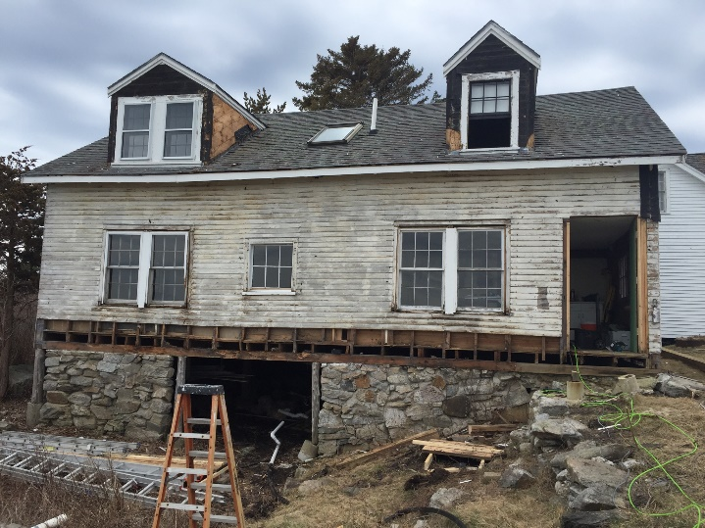Last week, we enjoyed a successful transition from winter mode to spring/open-up mode. Alex de Steiguer – who has served as Winter Caretaker for 20 winters – moved off the island on April 10, replaced by a small group of stalwart senior staff members. As of yesterday, ten employees were on island actively preparing for the upcoming conference season, and four contractors were hard at work on several projects, with an early focus on the Oceanic 2nd floor bathrooms and Kiddie Barn upgrades (see photo to right). Strategic Facilities Planning Committee Chair Dick Case switched the solar power/battery system over to “summer mode” last week after a successful winter season.
- On April 7, we had a productive meeting with Underwood Engineering and Altus Engineering on various design aspects related to our new wastewater treatment/water reclamation facility. We expect to receive all anticipated deliverables from Underwood by the end of June. We are awaiting official word on the status of our CWSRF loan application from the NH Department of Environmental Services, and we remain optimistic about this funding option.
- We recently completed our primary property and excess property insurance renewals, moving to a new primary property carrier (Tudor Insurance Company/Validus). The quality of our overall coverage has improved with this move – for example, our previous deductible for wind and hail was $100K, and now it is $25K – and the overall expense of our property coverage has dropped (see March Financials for more information).

STEWARDSHIP
(NOTE: Director of Development Pam Smith and I have co-written this part of my report.)
- Please see the attached March AF Comparison Report for an update on how we are doing with the 2017 Annual Fund. The following chart compares our progress this year to the previous two years:
Year | Realized Gifts | Pledge Balance | Total | % to Goal | Total Donors
2017 | $48,509 | $0 | $48,509 | 9.9% | 172
2016 | $26,341 | $9,000 | $35,341 | 7.4% | 120
2015 | $27,233 | $15,500 | $42,733 | 9.2% | 101

- Our spring Annual Fund appeal was sent out on Friday (with some special appeals to be mailed separately next week).
- The Celia Thaxter Museum at Vaughn Cottage was recently featured in the National Endowment for the Humanities’ web series “50 States of Preservation”: www.neh.gov/divisions/preservation/featured-project/50-states-preservation-the-star-island-corporation-in-portsmouth-new-hampshire.
- Some Fund Development Committee (FDC) working groups recently held their first meetings – the Legacy Society working group met on April 11 and the donor recognition and policy work group met on April 12. We are excited by this new approach, and look forward to seeing how things develop. The FDC will next meet on May 10.
- On April 11, I was the featured speaker at the Isles of Shoals Historical and Research Association’s spring meeting, where I provided an overview of what Star Island is all about, and focused on Star’s rich history, the Green Gosport Initiative, and how we can use what we do and learn on Star Island to help make the world a better place.
- On April 15, we gathered for a beach clean-up in Rye (in partnership with the Blue Ocean Society), followed by an informative conversation about the Green Gosport Initiative. We are grateful to our event sponsor, Five Maples.
- We are gearing up for our donor and volunteer appreciation/celebration at the Kittery Community Center on May 23 – “Celebrating our Stars!” To find out more, and to register, visit www.starisland.org/programs/events. We are grateful to our event sponsors, Insource Services and Southport Printing.
- Planning for the 8th annual Gosport Regatta is well underway! We are working with the Piscataqua Sailing Association on event promotions (much earlier than usual), and sponsors for our September 17 event will be secured in the coming months.
- Maryellen Burke and Peter Randall, authors of Gosport Remembered, will be our featured speakers for our November 18 Starry Night event. This is the 25th anniversary of the book release, and Star will be reprinting the book as a commemorative edition in the coming months. In addition, we are working with the New Hampshire Society of Photographic Artists (NHSPA) for an exhibit to be held at the Discover Portsmouth Center in the month leading up to Starry Night. This year marks the 20th anniversary of the NHSPA conference on Star, and the exhibit will feature NHSPA photographers’ selected Star Island works from the past two decades. We will receive a portion of proceeds from all sales, and sponsors for these two events will be secured in the coming months.
- We are gearing up for our upcoming spring volunteer weekends, which begin May 12-14. Each year, we benefit from over 10,000 hours of on-island volunteerism!
- The Annual Meeting materials were disseminated on April 7 – all Corporation members are encouraged to review these materials carefully and, whenever possible, attend the meeting, which will take place at the First Church and Parish in Dedham, MA on Saturday, May 6. Preparations for this meeting, as well as for the Council of Conferences meeting to take place on the same day, are well underway.

The island is being readied, our first pre-season conference begins in less than one month, and our first regular season conference begins in less than two months!

With Star Spirit,
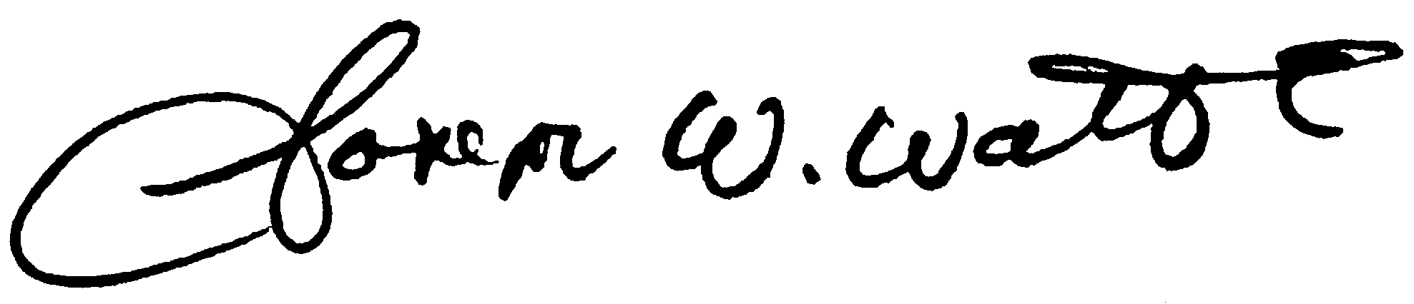
Joe Watts
Chief Executive Officer

