**Star Island Corporation (SIC)**

**Chief Executive Officer’s Report**

**June 5, 2018**

***Our Mission:*** *To own and maintain Star Island and such other property as the Corporation may hold or acquire, as a center for religious, educational, and kindred purposes consistent with the principles of the Unitarian Universalist Association and the United Church of Christ.*

***Our Vision:*** *To create on Star Island an environment that frees all who come to renew spiritually, explore matters of consequence, and gain knowledge about the world as it might ideally be.*

**COMMUNITY**

* We hosted two pre-season birding conferences last month, with a couple dozen birders in attendance for each program. We are excited to welcome Yearly Adults on Saturday, and Star Arts and Natural History starting June 16.
* We are grateful to Lisa Santilli for her excellent service over the last few years, and we are sorry to see her go – we wish her the best as she moves to Seattle later this month. Star is better off as a direct result of Lisa’s efforts. Please see Lisa’s final Communications Report, attached.
* The SIC/SIUCC marketing team met on June 1 to discuss a few topics, including the Kittery Festival on Star Island (August 4-5); hiring a marketing professional to work with SG conferences for 2019 and beyond; and an initial exploration of inviting a new conference (e.g. All Star 3) to join SG 2 Family & YES in 2019.
* We are pleased to announce that Ally Miner will become our Community Engagement Manager on June 30. Ally is being promoted after a comprehensive job search for a Community Outreach Manager, and we have tweaked this position to include programming and events – thus Ally will continue managing programs such as the SEA Star Program, Vaughn Cottage and the Rutledge Marine Lab.
* We have nearly finalized our 2018 Pelican roster. Over the last month, a number of people who had previously committed to working as a Pelican this year notified us that they were backing out of their commitment (for a variety of reasons), so we have had some challenges finalizing the roster for this summer. On May 10, the total number of open positions unexpectedly grew to four, so we sent out an email communication requesting more applicants. Last week, we had a full roster, but we then had another cancelation – thus we have one open position at this time.
* Pelican Orientation Week takes place next week. This intensive program covers many aspects of Pelican work and community living. We are pleased to be collaborating yet again with the Rye Fire Department and the Rye Police Department on aspects of our orientation program. We are also pleased to be offering our employees additional orientation addressing the issue of sexual harassment. Over the last few months we have sent out a series of orientation emails on specific topics, such as customer service and alcohol policies – these emails have been sent to Pelicans in advance of their arrival on the island with the hope of supplementing and spreading out the core on-island orientation program.
* The Center for Ethical Living and Social Justice Renewal ([www.celsjr.org](http://www.celsjr.org)) is providing all of our employees with diversity/inclusion and racial justice training over a two-day period, June 25-26.
* Year-round and seasonal professional staff enjoyed a productive spring staff retreat on May 30, with a particular focus on reviewing our alcohol policies in advance of Pelican Orientation Week and the conference season.
* Our Alcohol Safety & Awareness Task Force met last night to discuss a number of topics, including discussing our plans for Pelican Orientation Week and for the several town hall-style meetings we have scheduled during major conferences this summer. The task force will next meet on July 23.
* We continue to make good progress with changing our retirement plan. On May 9, our ad hoc investment committee met to review the proposed initial investment options, which will go into effect on July 1, when we make the change from TIAA-CREF to The Principal. Official notice of the change in our retirement plan has been sent out to all participants (current and former employees). An employee education meeting is scheduled for this Friday.

**ECONOMIC**

* As of June 1, we received 2,999 registrations representing 17,531 bed nights (86% of our 20,450 bed night goal). Please see the attached bed night report for more details. Last year at this time, we had registrations for 17,503 bed nights (86% of our 2017 goal), and in 2016 at this time, we had 17,363 bed nights (88% of our 2016 goal). Overall, we are pleased to be on pace with last year, and we are optimistic that we will meet our budgeted bed night goal for this season. As of June 1, we needed to achieve 2,919 (net of cancelations) bed nights to reach our budgeted goal.
* Our 2017 Form 990 has been filed with the IRS and the State of NH, as was the 2017 Form 990 of the Star Island Permanent Trust Fund. Our A-9 Form (real estate exemption) and A-12 Form (charitable organization financial statement) have also been filed with the Town of Rye. Also on the financial filing front, we recently submitted our 2017 Economic Census report (due every five years) and our Form 5500 (Annual Return/Report of Employee Benefit Plan).
* The Finance Committee meets tomorrow night to discuss several topics, including reviewing our YTD financial statements, reviewing the committee’s charge and setting goals for the year ahead. The committee will also review the attached Draft Five-Year Financial Plan, with a goal of providing input to inform a final draft of the plan. As a reminder, the final draft of the Five-Year Financial Plan will be part of the Long-range Integrated Financial Tool (LIFT), which will be completed this fall.
* Treasurer Jeff Loewer, Kristen King (Insource) and I met on May 29, and we plan to continue to meet on a regular basis over the next several months as we navigate a successful SIC Finance Department and Treasurer transition.
* We are currently projecting a net operating gain of $322K (vs. budget of $319K) – please see the attached April Financials for more information. The May Financials are expected to be completed on schedule, later this month.
* We have received three Clean Water State Revolving Fund (CWSRF) loan disbursements to date, totaling just under $14K.
* We are grateful to the Isles of Shoals Association, UU, for its generous spring gift of $20K, which was presented to the Star Island Corporation last month.
* We just started borrowing from our credit line with Optima Bank. While we still rely on this important cash flow vehicle, it is reassuring to know that we no longer need to borrow for the majority of each year.

**ENVIRONMENT**

* We are in the final stages of a successful open-up, which is resulting in some major improvements, such as the Oceanic Rehabilitation, Phase IV project (see photo, right) – an LCHIP site visit is scheduled for this project on Thursday. Other significant improvements include the Shack renovations, fixing up the Lobby alcove area, construction of shore side facilities, installation of grease traps and replacement of the Main Pump Station for our wastewater treatment facility (current and future facilities), replacement of the floor in Lawrance and much more.

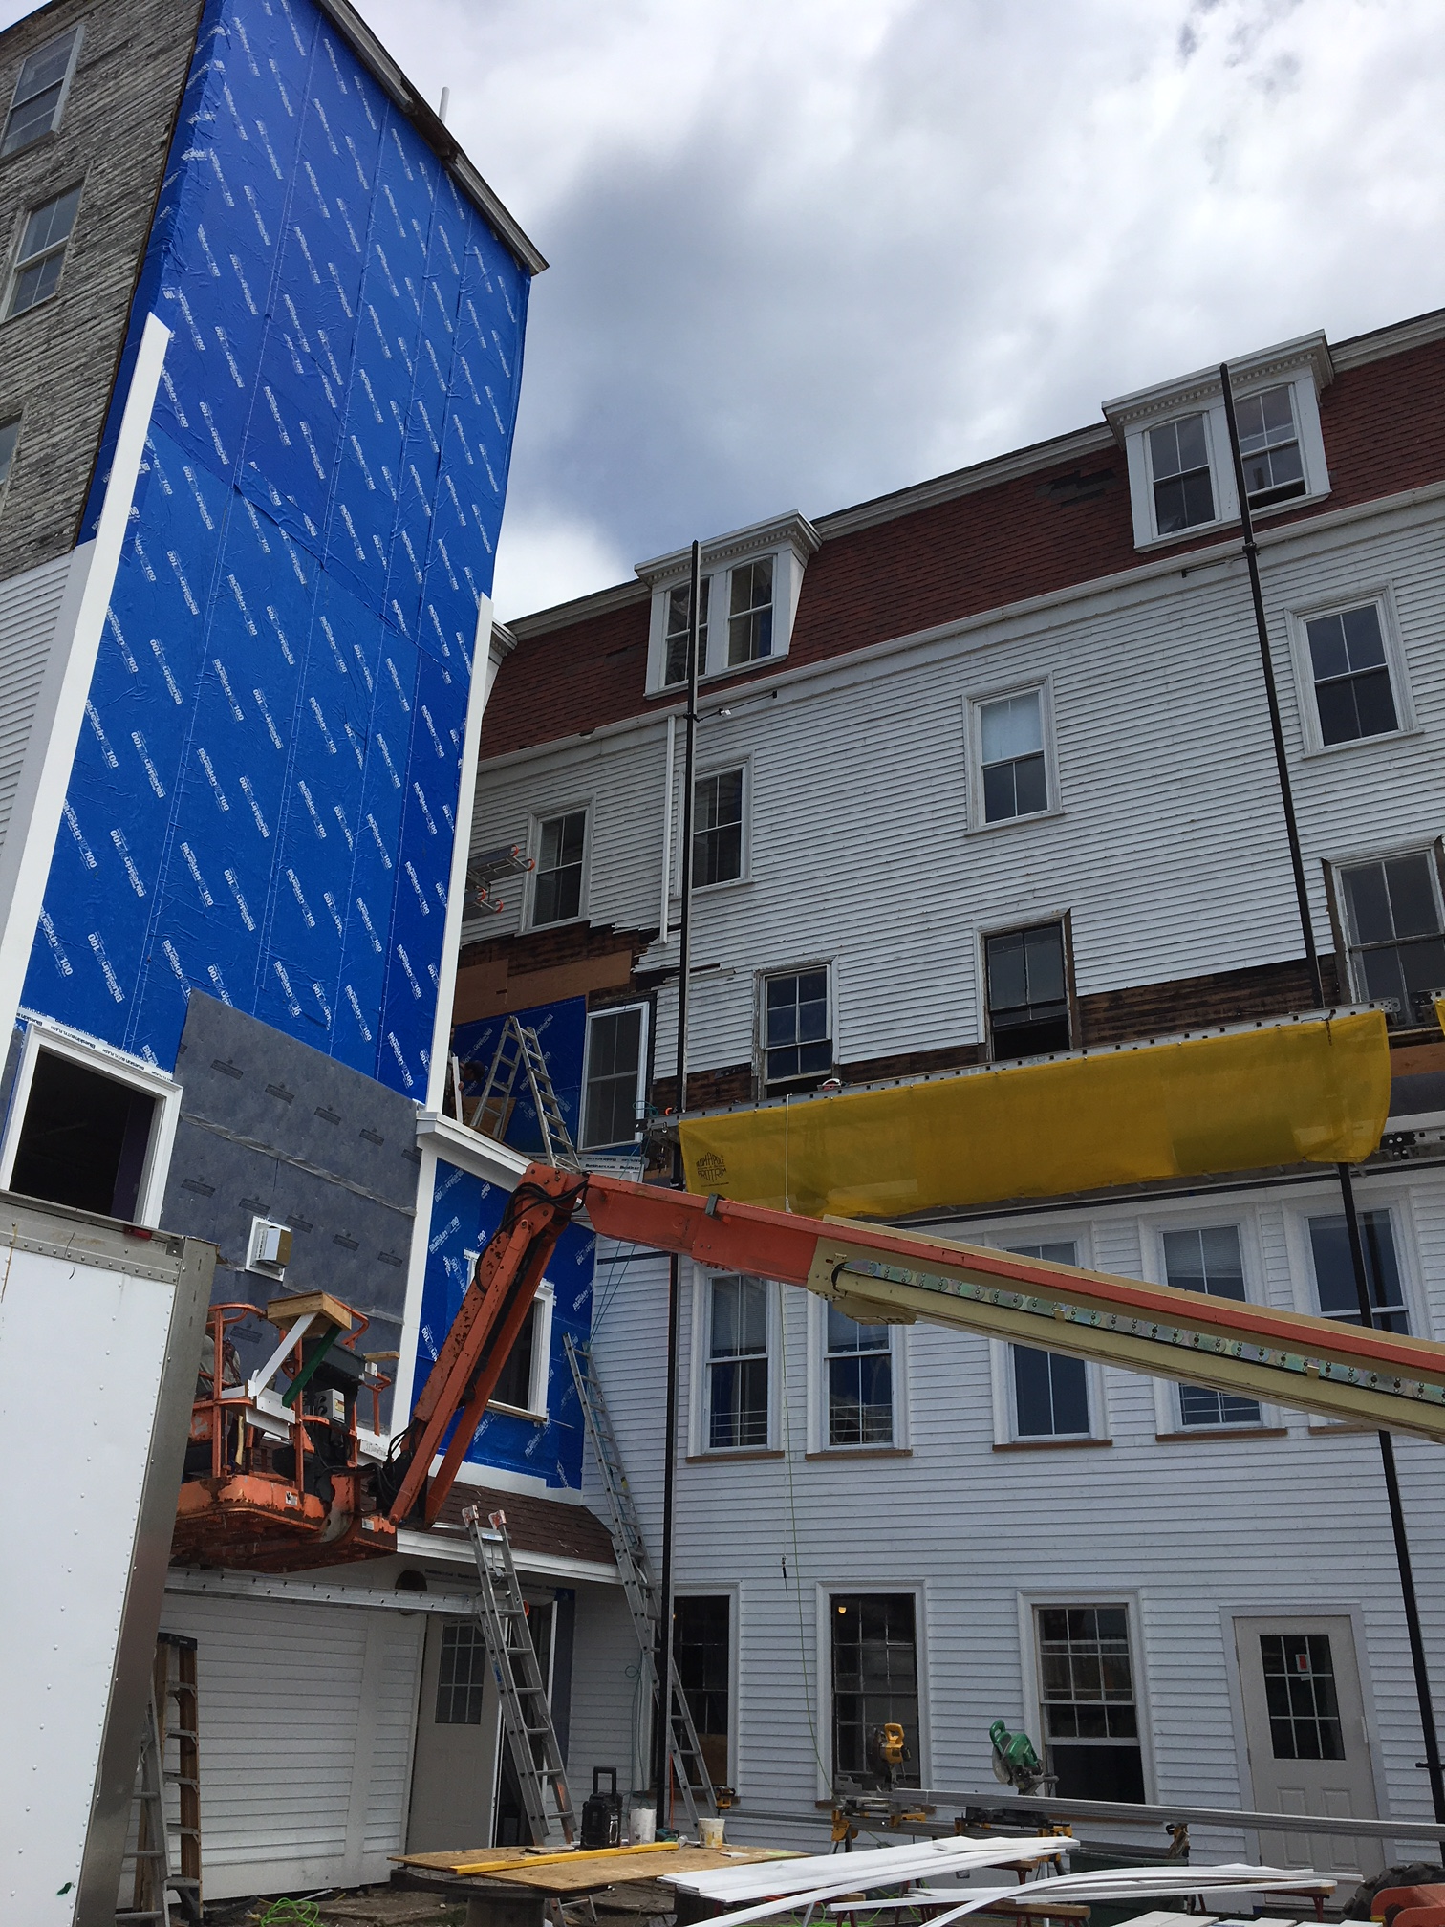

* Our largest 2018 capital expenditure is projected to be our new wastewater treatment/water reclamation facility. Our collaborative work with the New Hampshire Department of Environmental Services (NHDES) continues – we have received a draft response to our effluent reuse pilot program proposal, and expect to finalize this response in the coming weeks. On May 18, we had our 30% Basis of Design meeting with NHDES and Underwood Engineers, and we expect to submit 90% plans and specifications to NHDES in the near future. Our goal is to finalize plans by next month, advertise construction bids in August, and award a construction contract in September.
* The M/V Perseverance has been sitting in dry dock for some time. The “Percy” is a great workboat, and it remains in serviceable/good condition. We are in the process of securing a couple of value assessments of the Percy, and provided that the price is right, we are contemplating selling the vessel. We currently have the luxury of being in a position to make a sale on our terms. If we do sell, and later find ourselves in the position of needing to purchase another boat, we could do so – and at that time purchase a vessel capable of carrying paying passengers (something the Percy is not licensed to do). If circumstances unfold in a favorable way, a sale of the Percy could come as soon as this summer. There is no immediate pressure to sell the Percy if circumstances are unfavorable.
* On May 24, the Rye Fire Department (RFD) conducted our fire safety inspection, during which we received our signed occupancy permits (we had already received our annual controlled burn permit). The following individuals were present for the inspection: RFD Chief Mark Cotreau, RFD Lt. Jeff DiBartolomeo; RFD Firefighter Lexi Gorski; Jeff Murphy of SFC (our professional fire safety consultant); and, representing staff, Jack Farrell, John Bynum, Roger Trudeau and Hannah Swomley. As is normally the case, there are a few items for follow up, though no significant deficiencies were noted. This was Chief Cotreau’s first visit to Star Island, having become the cheif relatively recently. Chief Cotreau, who is a reasonable, positive and helpful professional, had a few questions about some of our operational practices and equipment, and we will be working with him over the next several months to answer his questions and make changes, as needed. The chief was generally impressed by our facilities and our attention to fire safety. Overall, the inspection, which included all of the principal buildings, was very cordial and collaborative, as has been the experience over the past several years.
* Kaley Dvorak, a Masters in Engineering student at Tufts University, is our climate change intern. Kaley’s internship, which has been approved by her college advisor, began in the winter and will run through August. Kaley is working to evaluate the potential impacts of various sea level rise scenarios on Star Island, and to help us create an educational/public awareness program.

**STEWARDSHIP**

*(NOTE: Director of Development Peter Squires and I have co-written this part of my report.)*

* As of May 31, the Annual Fund (AF) had realized $113,145 in gifts, with a pledge balance of $9,517, for a total of $122,662 (24% of our 2018 goal of $505,000), with 129 recurring monthly donors. The May AF Comparison Report, which details the breakdown of these gifts by giving group, is due out soon. The following chart compares progress this year to the previous two years:

|  |  |  |  |  |  |
| --- | --- | --- | --- | --- | --- |
| **Year** | **Realized Gifts** | **Pledge Balance** | **Total** | **% to Goal** | **Total Donors** |
| **2018** | $113,145 | $9,517 | $122,662 | 24% | In May AF Report |
| **2017** | $99,962 | $8,725 | $108,687 | 22% | 327 |
| **2016** | $103,388 | $9,580 | $112,968 | 24% | 323 |

* Please find attached our Donor Bill of Rights and Confidentiality Agreement.
* The Fund Development Committee met on May 30, with a focus on developing fundraising strategies for September conferences.
* Peer-to-peer fundraising efforts for the Shack and Underworld renovations have yielded nearly $9K so far in 2018, bringing our total raised for these projects over the last three years to $58K (including $20K donated by the 2016-2017 Pelicans). The web page for this effort remains active ([www.starisland.org/pelicanprojects](http://www.starisland.org/pelicanprojects)) – please take a look and share it with your Pelican friends!
* On May 6, the Unitarian Universalist Congregation at Shelter Rock voted to award the Unitarian Universalist Alliance of Camps and Conference Centers (UUACCC) a Large Grant of $100,000. SIC’s share – $14,280 – will go towards fire safety improvements on Star. As previously reported, SIC is both a co-applicant and the administrator of the grant on behalf of the UUACCC.
* We also recently received a $4,500 grant from the Fuller Foundation in support of 2018 arts programming on Star.
* We are awaiting word on some other grant applications, including our $25K request of the McIninch Foundation, our $25K request of the Cogswell Benevolent Trust and our $1K request of the Isles of Shoals Historical and Research Association – all in support of the Brookfield/Rutledge Marine Lab project. We expect to hear soon about our $20K request of the UU Funding Program in support of the Beloved Community Project.
* Our May 8 fundraiser at Flatbread in Portsmouth was attended by many Shoalers, generating a $537 donation from Flatbread, as well as $330 from raffle ticket sales. The raffle winner secured an overnight visit for two to the Gosport Regatta!
* Speaking of which, registration for the ninth annual Gosport Regatta is live ([www.starisland.org/regatta](http://www.starisland.org/regatta)). We have secured $3K in corporate sponsorships from five organizations so far. We are finalizing our marketing efforts, including postcard invitations, scheduled email blasts, a program booklet and placement on various community calendars. Ally Miner will be assuming coordination of this event upon Lisa Santilli’s departure.
* Please find attached the staff tactics version of our Strategic Plan, 2017-2020. Our tactics are the means by which we aim to achieve the objectives in our plan (just as the stated objectives help us to achieve our goals). As these tactics cover a four-year period, some of them have already been completed, some are in progress and some have yet to begin in earnest.
* The Annual Meeting of the Star Island Corporation took place on May 5 at the First Congregational Church in Holliston, MA. 148 Shoalers were in attendance; slightly more than last year, though slightly less than our ten year average attendance of 155. Special thanks to Kate Brady, Office Manager, for her excellent work behind the scenes helping to make our Annual Meeting enjoyable and successful.
* The spring Council of Conferences (CoC) meeting also took place on May 5. Delegates focused on how best practices for conference governance impact overall conference success, including engagement and conference attendance. The delegates also discussed the concept of having a position on the CoC Board be filled by a member of the SIC Board – a final decision on this will be made at a future date.
* We are in the process of benefiting from several spring volunteer weekends this year. Volunteers are cleaning rooms, weed-whacking and mowing, repairing dozens of chairs, maintaining our gardens, painting several rooms, completing carpentry projects, and much more. We would not be able to accomplish all that needs doing on Star Island without our amazing volunteers.

YAC and the rest of the Pelicans arrive in just a few days, and we are all looking forward to another great season on Star Island.

With Star Spirit,

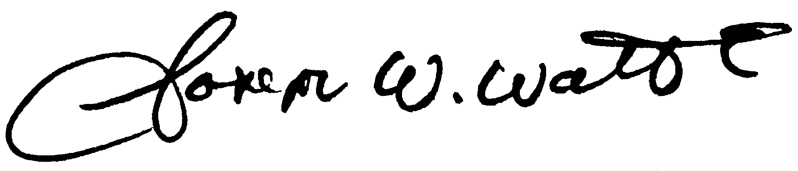

Joe Watts

Chief Executive Officer